Document generated on 11-30-2024

# Data Analysis for incident Dump

## Initial Description of the Data Received

|  |  |  |  |  |  |  |  |  |  |  |  |  |  |  |  |  |  |  |  |  |  |  |  |
| --- | --- | --- | --- | --- | --- | --- | --- | --- | --- | --- | --- | --- | --- | --- | --- | --- | --- | --- | --- | --- | --- | --- | --- |
|  |  |  |  |  |  |  |  |  |  |  |  |  |  |  |  |  |  |  |  |  |  |  |  |

## Column Fill Statistics

|  |  |  |
| --- | --- | --- |
| Column | Filled Count | Missing Values % |
| Number | 2227 | 0 |
| Priority | 2227 | 0 |
| State | 2227 | 0 |
| Assignment group | 2227 | 0 |
| Assigned to | 2226 | 0 |
| Short description | 2227 | 0 |
| Created | 2227 | 0 |
| Updated | 2227 | 0 |
| Closed | 2043 | 8 |
| Resolved | 2051 | 8 |
| Task type | 2227 | 0 |
| Description | 2207 | 1 |
| Parent | 0 | 100 |
| Parent Incident | 32 | 99 |
| Configuration item | 1325 | 41 |
| Impact | 2227 | 0 |
| Urgency | 2227 | 0 |
| Category | 2227 | 0 |
| Subcategory | 2227 | 0 |
| Resolution notes | 2063 | 7 |
| Resolution code | 2064 | 7 |
| Resolved by | 2051 | 8 |
| Additional comments | 1930 | 13 |
| Comments and Work notes | 2081 | 7 |

Original data preprocessed as field names to lowercase and no spaces ['number', 'priority', 'state', 'assignment_group', 'assigned_to', 'short_description', 'created', 'updated', 'closed', 'resolved', 'task_type', 'description', 'parent', 'parent_incident', 'configuration_item', 'impact', 'urgency', 'category', 'subcategory', 'resolution_notes', 'resolution_code', 'resolved_by', 'additional_comments', 'comments_and_work_notes'].

The fields to be drop (>20% missing values) are ['parent', 'parent_incident', 'configuration_item'].

Definitive fields to be processed and analyzed are ['number', 'priority', 'state', 'assignment_group', 'assigned_to', 'short_description', 'created', 'updated', 'task_type', 'description', 'impact', 'urgency', 'category', 'subcategory', 'resolution_notes', 'resolution_code', 'resolved_by', 'additional_comments', 'comments_and_work_notes'].

## Unique values

Unique priority are = 4

Unique state are = 5

## Notes

## Analysis of priority field.

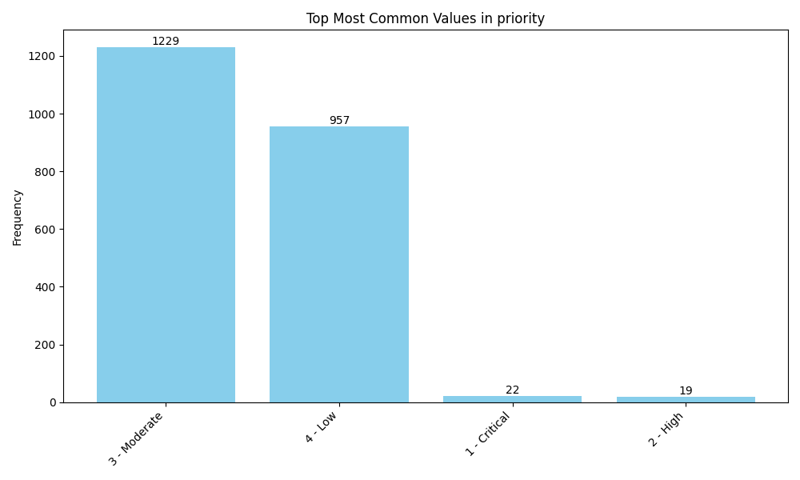

## Analysis of state field.

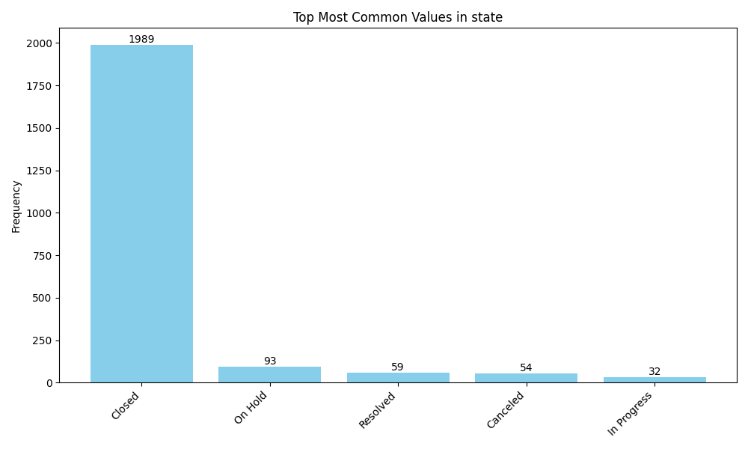

## Analysis of created_year field.

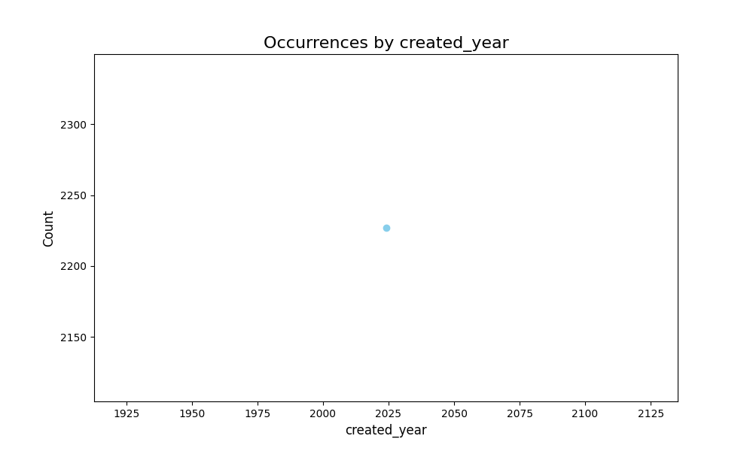

## Analysis of created_month field.

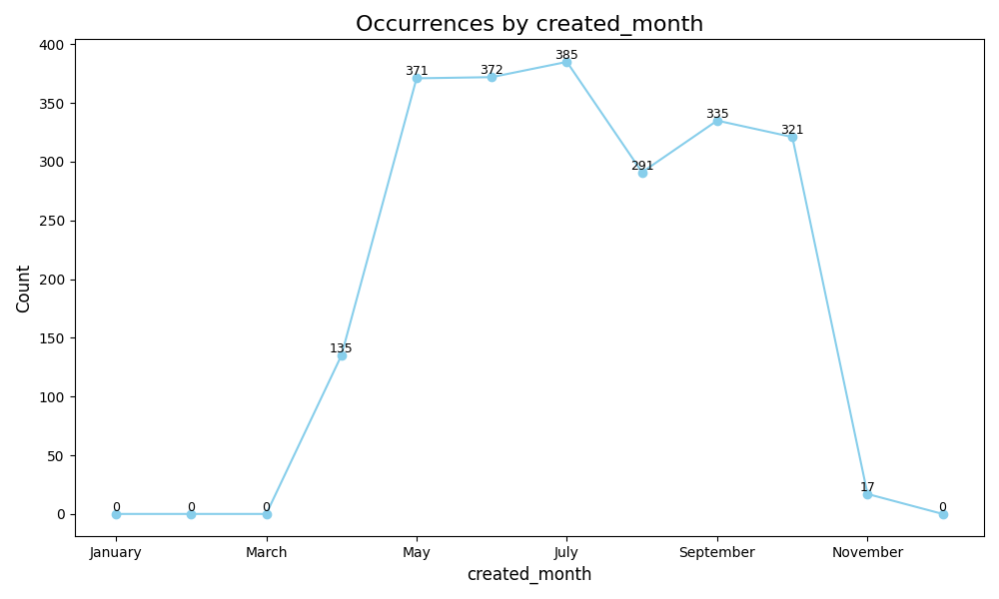

## Analysis of created_hour field.

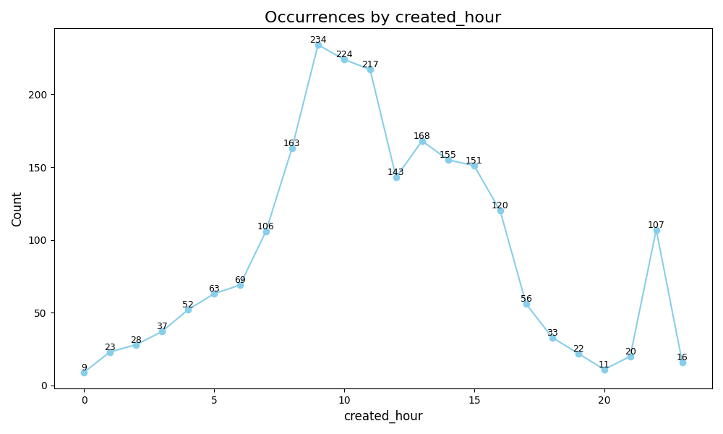

## Analysis of created_day_name field.

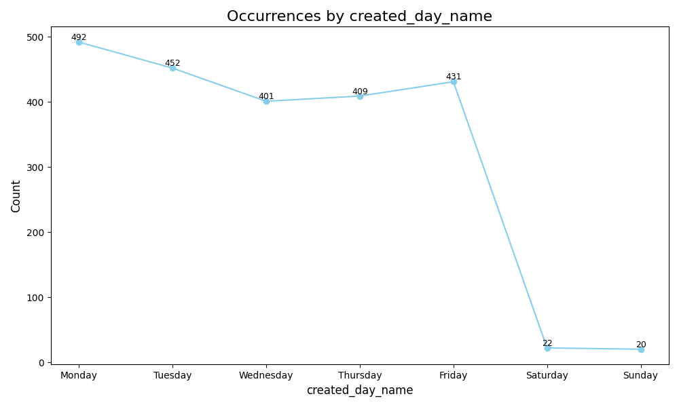

## Analysis of created_day field.

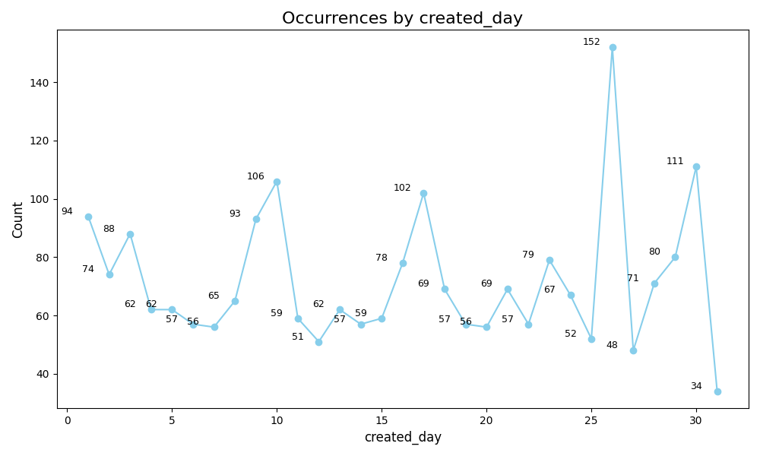

## Analysis of created_week_number field.

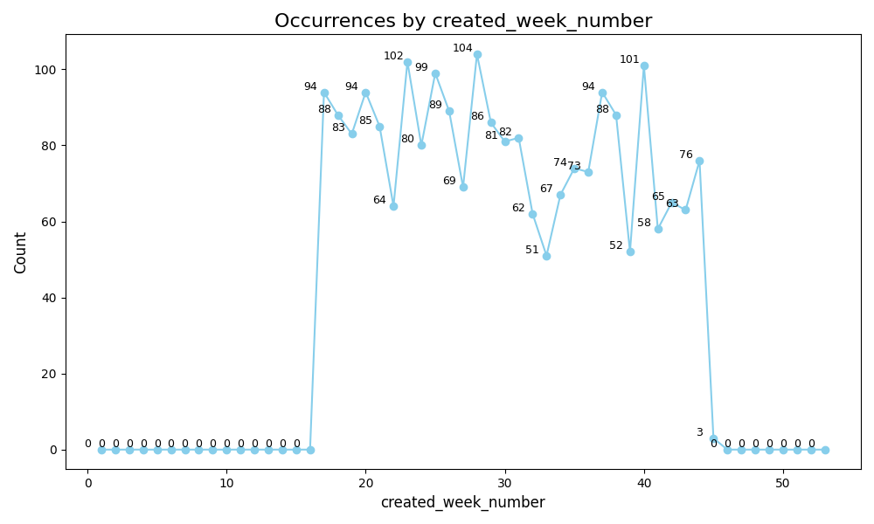

## Analysis of updated_year field.

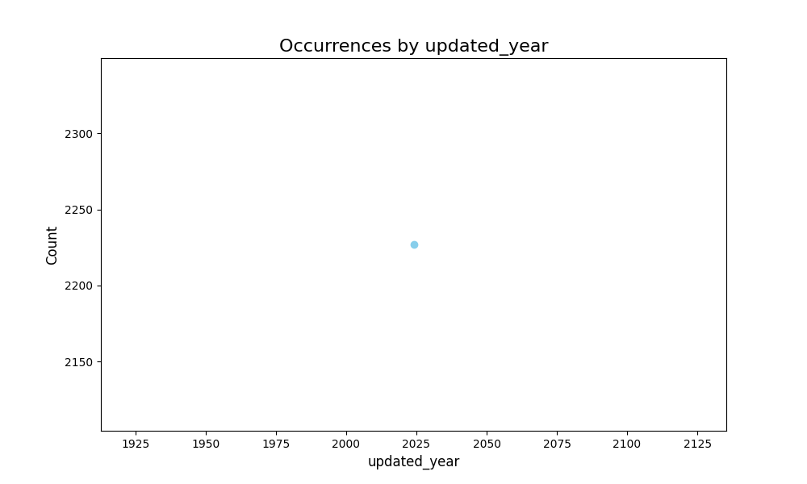

## Analysis of updated_month field.

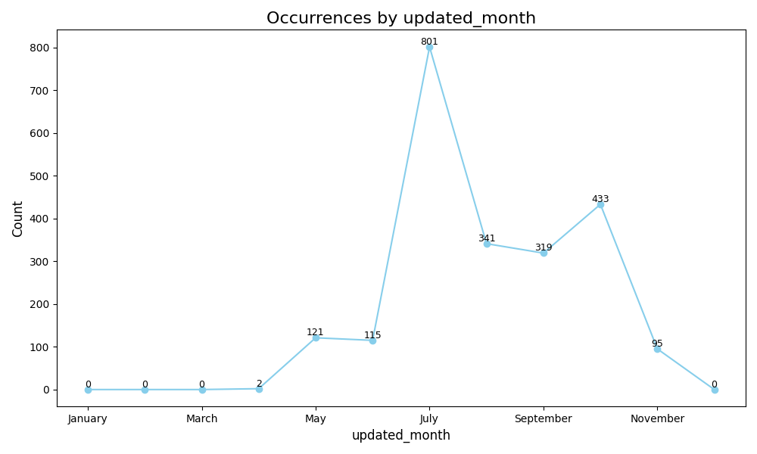

## Analysis of updated_hour field.

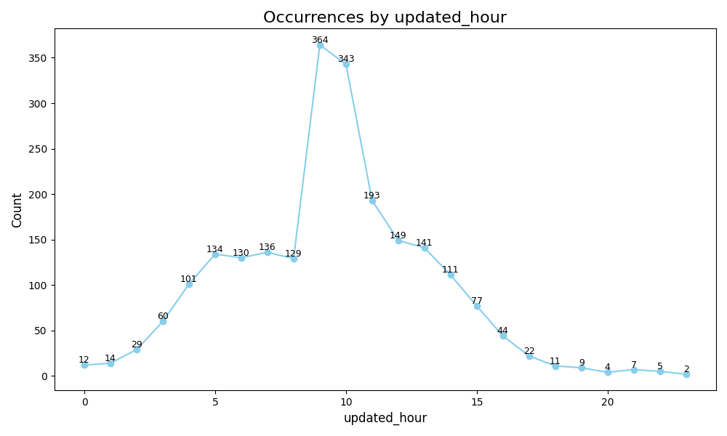

## Analysis of updated_day_name field.

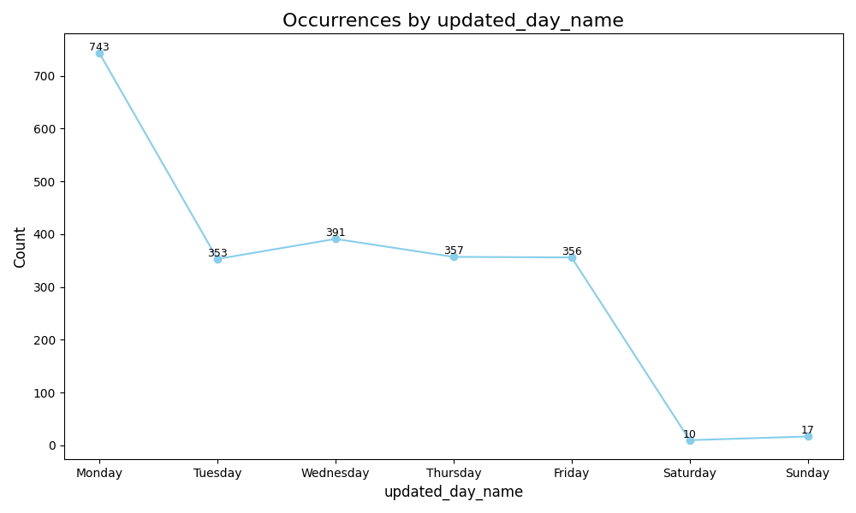

## Analysis of updated_day field.

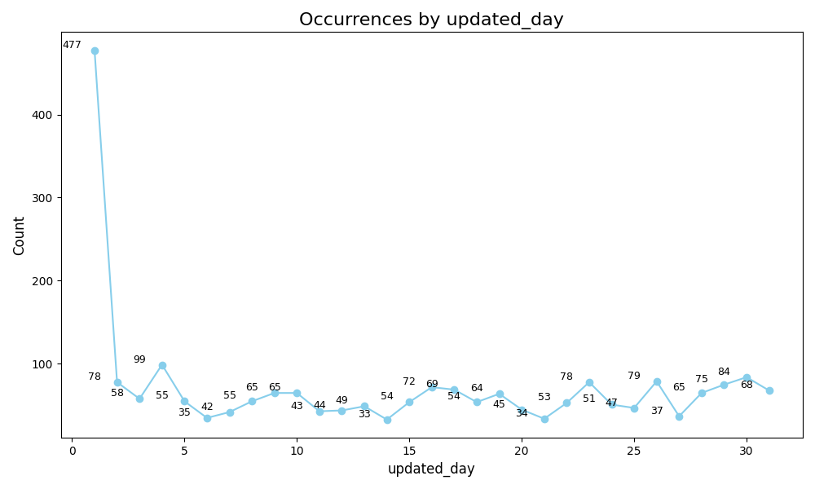

## Analysis of updated_week_number field.

